Lab 09c - Implement Azure Kubernetes Service

Task 1: Register the Microsoft.Kubernetes and Microsoft.KubernetesConfiguration resource providers.

In this task, you will register resource providers necessary to deploy an Azure Kubernetes Services cluster.

Sign in to the Azure portal.

In the Azure portal, open the Azure Cloud Shell by clicking on the icon in the top right of the Azure Portal.

If prompted to select either Bash or PowerShell, select PowerShell.

Note: If this is the first time you are starting Cloud Shell and you are presented with the You have no storage mounted message, select the subscription you are using in this lab, and click Create storage.

From the Cloud Shell pane, run the following to register the Microsoft.Kubernetes and Microsoft.KubernetesConfiguration resource providers.

Code

Register-AzResourceProvider -ProviderNamespace Microsoft.Kubernetes

Register-AzResourceProvider -ProviderNamespace Microsoft.KubernetesConfiguration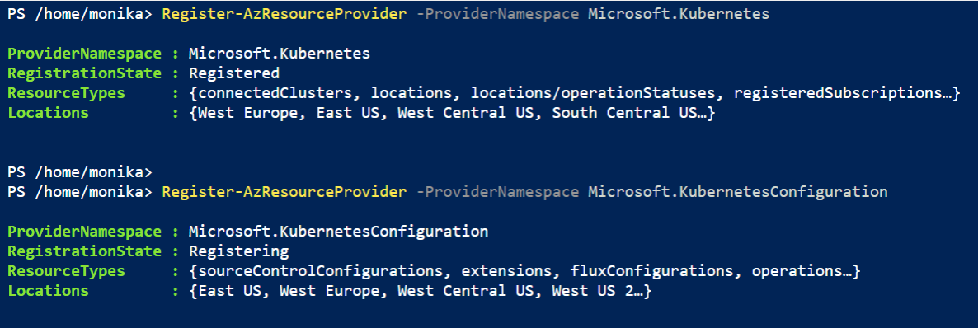

Close the Cloud Shell pane.

Task 2: Deploy an Azure Kubernetes Service cluster

In this task, you will deploy an Azure Kubernetes Services cluster by using the Azure portal.

In the Azure portal, search for locate Kubernetes services and then, on the Kubernetes services blade, click + Create, and then click + Create a Kubernetes cluster.

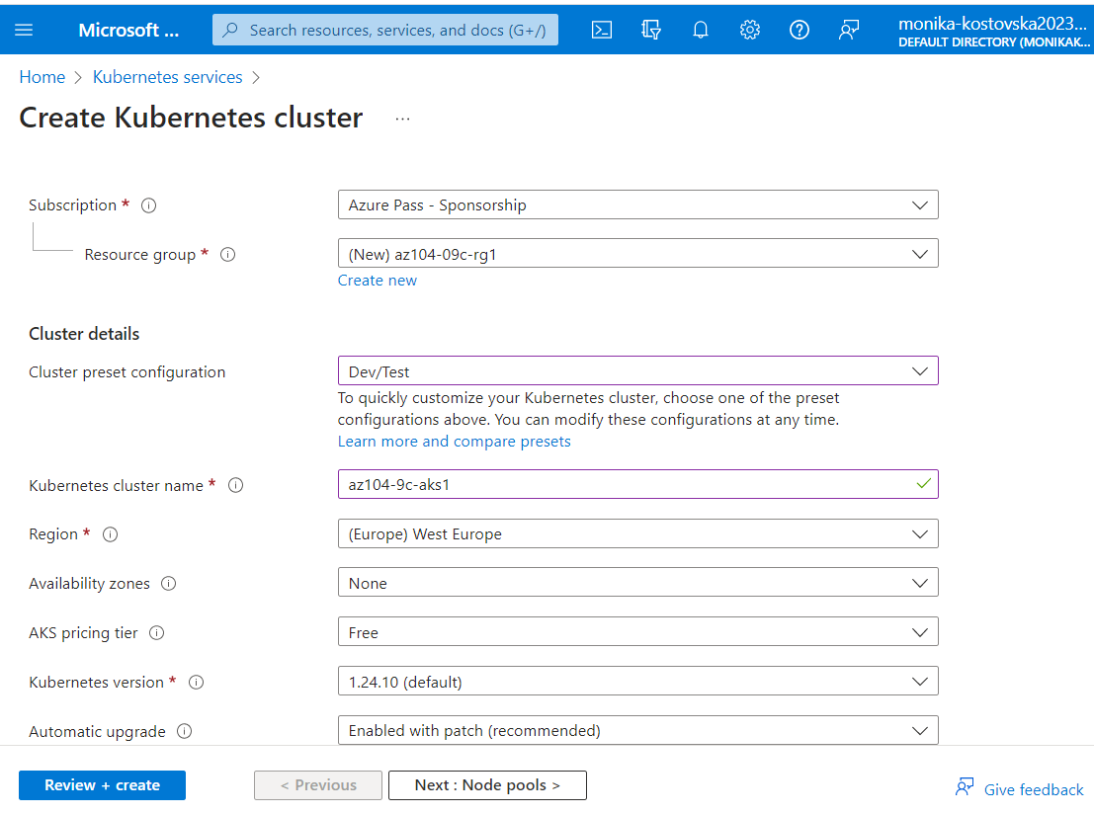

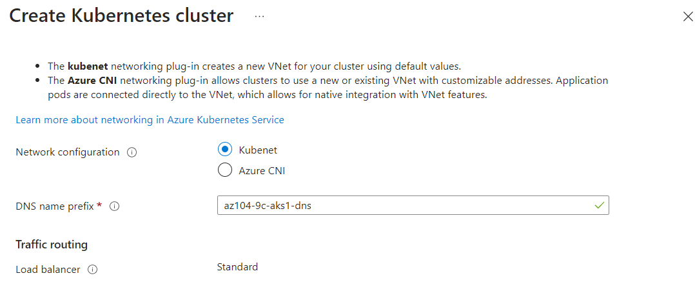

Task 3: Deploy pods into the Azure Kubernetes Service cluster

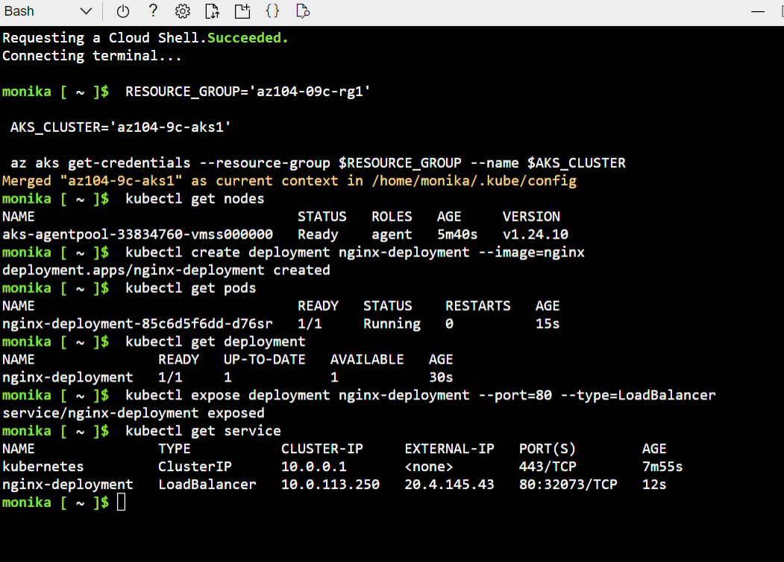

Open a browser window and navigate to the IP address you obtained in the previous step. Verify that the browser page displays the **Welcome to nginx!** message.

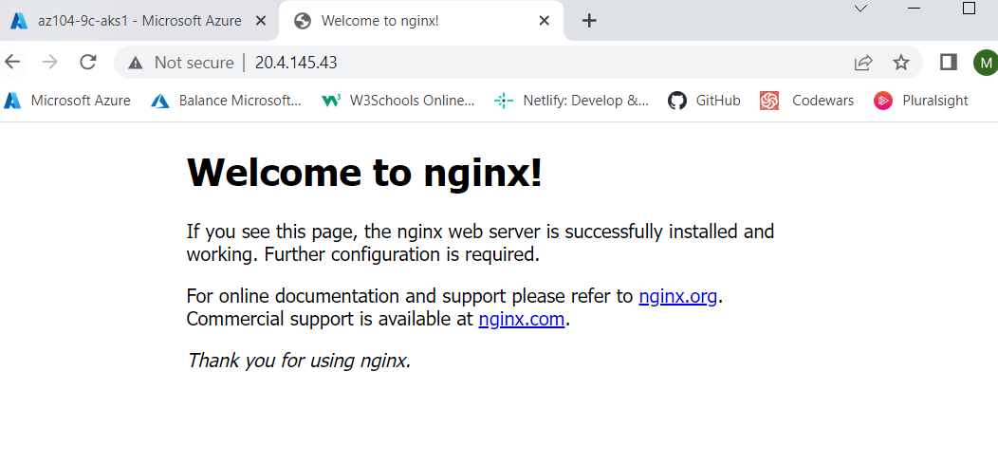

Task 4: Scale containerized workloads in the Azure Kubernetes service cluster

From the Cloud Shell pane, and run the following to scale the deployment by increasing of the number of pods to 2:

From the **Cloud Shell** pane, run the following to verify the outcome of scaling the deployment:

From the **Cloud Shell** pane, run the following to scale out the cluster by increasing the number of nodes to 2:

Scaling the deployment by increasing the number of pods to 2  
Verifying the output and scale out the cluster by increasing the number of nodes to two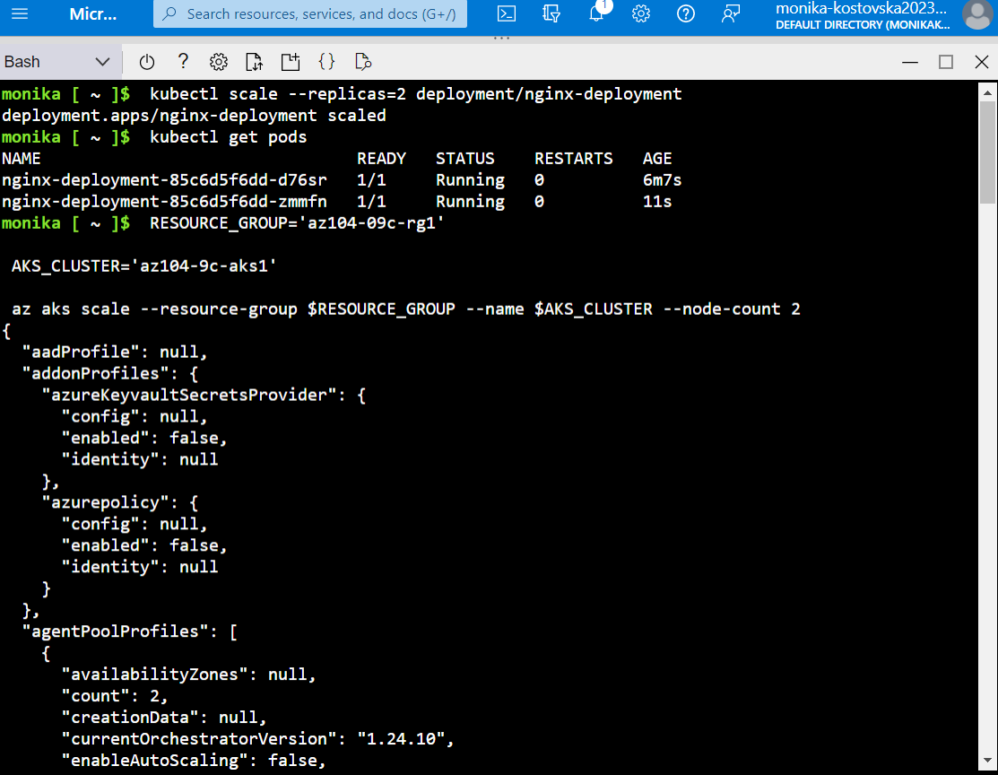

From the **Cloud Shell** pane, run the following to verify the outcome of scaling the cluster:

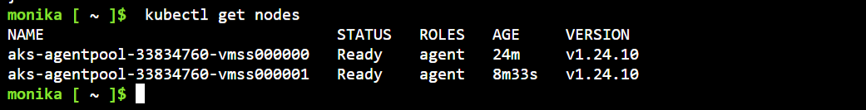

From the **Cloud Shell** pane, run the following to scale the deployment:

From the **Cloud Shell** pane, run the following to verify the outcome of scaling the deployment:

From the **Cloud Shell** pane, run the following to review the pods distribution across cluster nodes:

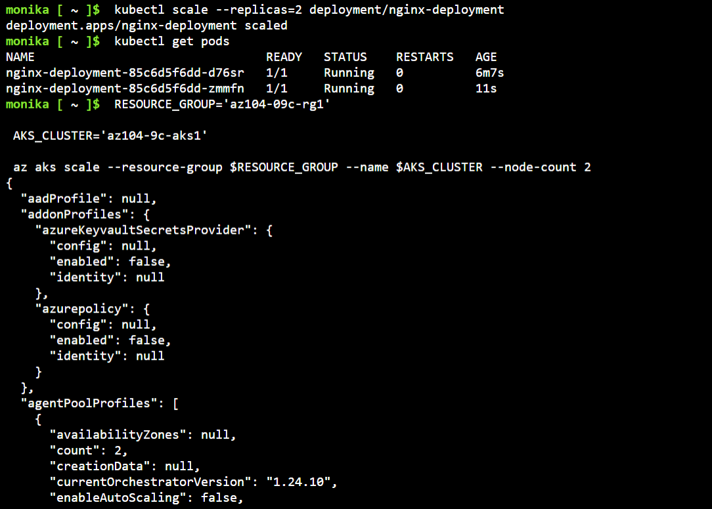

From the **Cloud Shell** pane, run the following to review the pods distribution across cluster nodes:

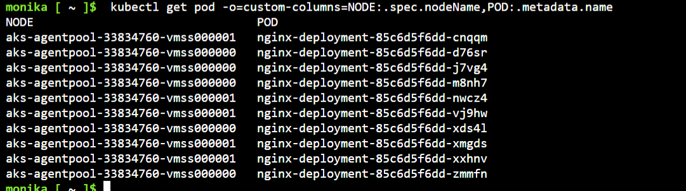

From the **Cloud Shell** pane, run the following to delete the deployment:

